PRESS KIT
Press release related to 14th edition of Blechexpo - November 2019

AMADA exhibiting at Blechexpo 2019

- The next generation of fiber laser technologies for significantly higher speed and savings potential in cutting and welding
- Full performance in high and low kW-classes
- Time-saving complete solutions for the entire process value added chain
- Compact entry-level machine for fiber laser welding
- AMADAs refined portfolio provides more flexibility in production than ever before

Haan, 05.11.2019. - At the 14th edition of Blechexpo (05th to 08th of November 2019 in Stuttgart, Germany) AMADA GmbH will exhibit its further refined portfolio with innovative processes for the most flexible sheet metal processing. In Hall 3, booth 3307, the machine manufacturer will present a comprehensive overview of the latest technologies in the field of laser cutting, laser welding and bending, automation and software.
On the one hand, the producer focuses on own developments to increase productivity and save costs in the segment of fiber laser technologies, covering the entire spectrum of sheet metal processing. On the other hand, solutions for a smart factory in the spirit of IoT will be exhibited, which enable customers to produce at an optimum cost-benefit ratio.
Highlights of the fair include fiber laser technologies for flatbed, tube and profile processing as well as laser welding. The perfect symbiosis of an in-house developed, highly efficient oscillator in interaction with the respective machines is fundamental to the high performance and manufacturing quality AMADA machines provide. For its appearance at Blechexpo, the exhibitor relies on the presentation of the proven and further improved ENSIS series as well as on the live demonstration of the latest technological developments. Of particular interest will be a fiber laser cutting process of the latest generation, which opens up new potentials in productivity, speed and quality.

In the field of machine monitoring, AMADA will focus on its IoT concept V-factory, which offers smart machine monitoring in order to maintain full control of machine utilization and production processes at all times - in the factory and everywhere. Users thus keep an eye on production in order to secure continuous workflows 24/7 and to counteract bottlenecks and downtimes.
In the field of bending, AMADA is focusing on ergonomic, space-saving solutions for the processing of small to very small bending parts with a high degree of complexity, as well as bending with a patented automatic tool changer. Ideal for the production of changing batch sizes and set-up processes without loss of time. The bending robot to be exhibited enables continuous bending process for particularly small components while maintaining consistently high quality with man poor operation..
Another focus of the exhibition is on tool technology and accessories. The durable AMADA tooling products for bending and punching requirements, allow to minimize set-up times, added value can be optimized.
AMADA's production solutions enable customers to flexibly process almost all types of production orders and to manage large variants of different batch sizes in the shortest possible time with the highest quality.

Details about AMADA at Blechexpo:
Hall 3
Booth 3307
05th to 08th of November 2019 in Stuttgart, Germany

Press release 1

VENTIS-3015AJ 4kW
Uncompromising stainless steel and aluminum cutting with the next generation of Fiber Laser
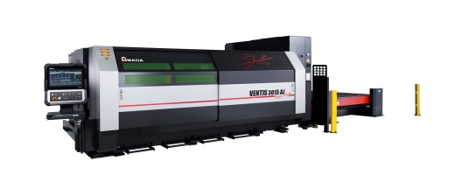
The first cutting laser worldwide of a new fiber laser generation with 4 kW laser power and only one laser module offers the possibility of cutting sophisticated materials without compromise. For the first time, stainless steel, aluminum and other materials can be processed with a cutting quality equal to that of a CO² Laser. The use of an innovative process means that the system is able to oscillate the laser beam in the kerf based on predefined patterns. This not only results in a significantly increased cutting speed, it also guarantees an absolutely precise bevel free cut, for example when processing mild steel by oxygen. The surface roughness achieved in the fiber laser field is unequaled and is only comparable to the quality of a CO² laser. At the same time, the fiber laser burr which is otherwise usual can be almost completely excluded.

Press release 2

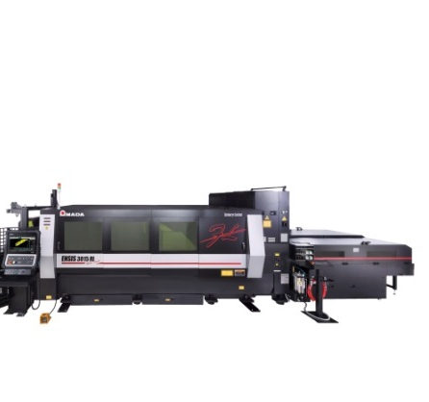
ENSIS-3015 RI 3 kW
All-in-one solution for sheet metal, tubes and profiles

Combining AMADA’s ENSIS 3 kW flatbed laser cutting technology with the Rotary Index (RI) tube and profile cutting system, AMADA is exhibiting a machine with very wide range applications. ENSIS technology, with variable beam control, allows for high speed thin material processing and stable thick mild steel cutting. Round, square and rectangular tubes can all be processed, as well as channel and angle sections. Flat sheet to tube changeover is done in less than 2 minutes.

Press release 3
FLW-30000 ENSIS M2
Compact Fiber Laser Welding cell with new space-saving cabin design and variable beam control
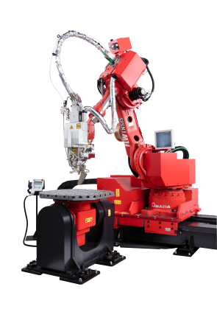
The FLW takes laser welding to a higher level of quality with a reduction of the total lead time. In addition our new solution is equipped with an ENSIS 3 kW fiber laser oscillator which covers many different welding applications through the variable beam control system. The machine features a filler wire function, which is used to ensure high quality, long welding applications and the beam weaving system which allows larger gap welding to be achieved. The compact fiber laser welding cell now offers the user a stationary variable twist and tilt table as well as a two-station rotary table integrated in the cabin wall, significantly reducing cycle times. Thus, this smallest of the FLW-ENSIS expansion levels fits perfectly into production environments with limited space.

Press release 4
HG-10034ATC
The solution in the race with short delivery times and decreasing lot sizes
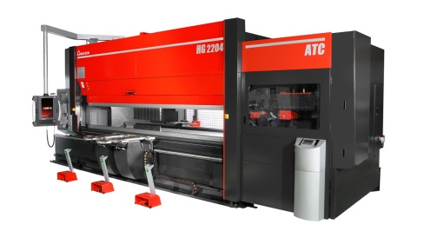
The fully automatic tool changer (ATC) in AMADA's HG press brakes cut setup times drastically compared to conventional systems. This maximizes manufacturing efficiency, especially in the case of small runs of complex parts demanding correspondingly frequent tool changes. At Blechexpo, AMADA will exhibit the expansion level HG-1003ATC with the active angle measurement on 3 points which assures the highest precision in terms of angle and linearity. The Delta-X back gauge until 150mm helps to manage even complex part geometries and the active angle measurement system BI-S enables accurate production from the first part on.

Press release 5
EG-6013AR
Automated bending for small and complex bending parts
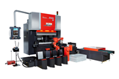
The EG-6013AR is equipped with an extremely versatile automatic robotic system as well as a special back gauge sensor system for high productivity. The concept of the EG-6013AR ensures maximum precision and long, unmanned running times in automatic mode. The machine comprises a servo-electric press brake with a press beam length of 1,300 mm and a press force of 600 kN. This works in conjunction with a robot that moves parallel to the machine, an automatic tool changer and gripper changer.

Press release 6
EG-4010
The innovative EG-4010 press brake for maximum productivity and ergonomics

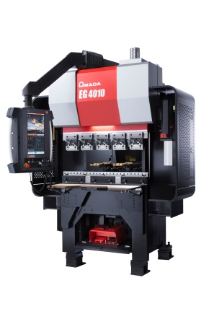
The new bending machine EG-4010 completes the AMADA portfolio as the first ergonomic servo-electric press brake with the unique AMADA DSP system and sets standards in speed, comfort, reduced electrical consumption and intuitive programming. With 40t and 1050 mm table length, it works perfectly for the production of small and precise parts. Furthermore, AMADA's Bi-J mechanical angle measurement system provides the highest quality on any material and thickness. In response to the risen demand for ergonomic machines, the EG-4010 comes with an ergonomic operator chair, front table, pendant arm and foot rest - all adjustable for highest operator comfort.

Press release 7
HFE3i-5012
Allround solution for maximum flexibility, safety and ergonomics
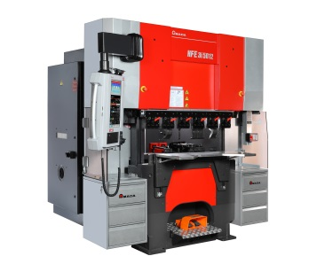
Based on the solid foundation of the HFE series, the network-compatible press brake HFE3i-5012 provides an allround solution for almost all bending tasks. With a processing spectrum from 500 kN to 4,000 kN and bending lengths from 1,250 to 6,000 mm, the HFE3i series offers solutions for many bending tasks. Due to this high flexibility and an opening width of 480 mm, the HFE3i-5012 masters a broad range of material thicknesses as well as complex part geometries. The ergonomic solution improves working conditions and relieves the operator in the working process.

Press release 8

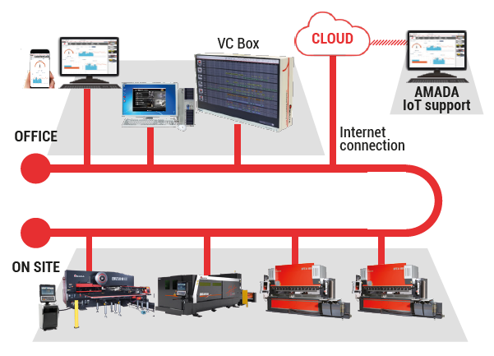
AMADA IoT-concept V-factory
AMADA’s IoT concept with production monitoring and interactive support
The next generation of AMADA’s comprehensive and network-based machine surveillance concept will be shown with two new features, allowing monitoring – anytime, anywhere. My V-factory visualizes the whole connected production environment at a glance. The optional new IoT-Support is the second element providing a direct-response customer service concept for error prevention and immediate support.

Press release 1

VENTIS-3015AJ 4kW
Uncompromising stainless steel and aluminum cutting with the next generation of Fiber Laser
The first cutting laser worldwide of a new fiber laser generation with 4 kW laser power and only one laser module offers the possibility of cutting sophisticated materials without compromise. For the first time, stainless steel, aluminum and other materials can be processed with a cutting quality equal to that of a CO₂ laser.

Cutting performance in a new dimension
AMADA is introducing a new fiber laser cutting system with the VENTIS-3015AJ 4kW which can overcome the current limitations of fiber laser technology using a revolutionary flexible beam guiding system. With only 4 kW laser power, the system is able to perform to a level that is usually only achieved by 6 or 8 kW systems. The use of an innovative process means that the system is able to oscillate the laser beam in the kerf based on predefined patterns. This not only results in a significantly increased cutting speed, it also guarantees an absolutely precise bevel free cut. The surface roughness achieved in the fiber laser field is unequaled and is only comparable to the quality of a CO₂ laser. At the same time, the so called fiber laser burr which is otherwise usual can be almost completely excluded.

Cuts through all materials – always with the highest possible beam quality
Flawless and consistent quality is a particularly decisive factor for demanding clients. AMADA VENTIS-3015AJ is the solution for this task due to a continuously maintained laser mode. As a result, the AMADA VENTIS-3015AJ achieves unusually high-quality results for a 4kW fiber laser. The beam parameter product (BPP) is maintained consistently at BPP ≤ 0,9 mm*mrad. Due to the diverse oscillating patterns of the laser beam, each task can be approached individually; thin as well as thick metal sheets can be cut at its individual maximum speed and with equally high-quality precision.

Additional cost savings as a secondary effect
In addition to its high capacity for performance, AMADA VENTIS-3015AJ also offers a high level of resource sustainability. The significantly higher processing speed provides an additional saving in costs for each manufactured part, because the required power and cutting gas can be further reduced to a significant extent.
(approx. 2,300 characters)

Technical data VENTIS-3015AJ
Laser | Own-developed fiber laser source with flexible beam pattern
Laserpower | 4000 W
Work range | 3000 x 1500 mm
Max. feed rate  (X-Y simultaneous) | 170 m/min
Special feature | The laser beam oscillates in the kerf based on flexible patterns.

Image material

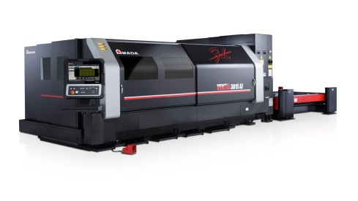 | The VENTIS-3015AJ stands for  perfect cutting results in  stainless steel, aluminum and  many other materials.
Source: AMADA GmbH

Further information:
AMADA GmbH
Press contact: Nicole Willuhn
Amada Allee 1
42781 Haan
Phone: +49 2104 2126-115
E-Mail: nicole.willuhn@amada.de
www.amada.de

Please provide evidence copy in the event of reproduction.

Press release 2
ENSIS-3015 RI 3 kW
All-in-one solution for sheet metal, tubes and profiles
The Rotary Index (RI) unit with integrated material measurement meets a high-performance 3 kW laser cutting system with ENSIS beam source. This all-in-one system is set up in seconds from sheet metal to tube and profile processing, shortening production cycles effectively.

Productive and flexible with ENSIS technology
The ENSIS-3015 RI 3 kW fiber laser cutting system is based on the successful ENSIS principle whose strength lies in own developed beam sources and the unique variable beam control for ultimate flexibility and productivity. Expanding on the AMADA FO-MII CO₂ laser system with Rotary Index, it provides all the advantages of fiber laser processing in terms of speed, profitability and cutting quality.

The variable beam control function provides the ENSIS-3015 RI with the flexibility to process all sort of material types and thicknesses, regardless of whether the material in question is stainless steel or a non-ferrous material such as aluminum, copper, brass or titanium.

For use in the ENSIS-3015 RI 3 kW, the latest generation of the Rotary Index unit has again been specially adapted. This contributes significantly to a rapid processing speed and accuracy, while the optimized tube guidance ensures practically scratch-free processing.

Switching between sheet metal, tube and profile processing in a trice
The additionally integrated measurement Touch-Probe sensor enables the quick and precise reference measurement of the component. The automatic nozzle changer, as well as the option to cut all materials and material thicknesses with a single cutting lens, reduces potential waiting and down times significantly. Separated tubes and profiles are safely caught in a special tub. The lateral sliding doors ensure optimal access and provide reliable protection against reflection and sparks.

Networked for even more performance
As most of the current AMADA machines, ENSIS-3015 RI runs with the newest AMNC-3i control system and network option, which guarantees easy and intuitive operation, contributes to set-up time minimization and provides a reliable analysis of machine data.

(approx. 2,200 characters)

Technical data ENSIS-3015 RI
Laser | Own-developed fiber laser beam source with variable beam control
Laserpower | 3000 W
Work range | 3000 x 1500 mm
Max. feed rate  (X-Y simultaneous) | 170 m/min
Special feature | Rotary Index for sheet-, tube- and profile cutting

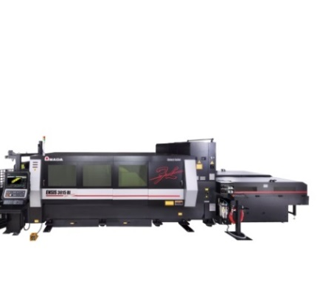

Image material
The ENSIS-3015 RI is an All-In-One machine
for sheet -, tube - and profile cutting

Source: AMADA GmbH

Further information:
AMADA GmbH
Press contact: Nicole Willuhn
Amada Allee 1
42781 Haan
Phone: +49 2104 2126-115
E-Mail: nicole.willuhn@amada.de
www.amada.de

Please provide evidence copy in the event of reproduction.

Press release 3
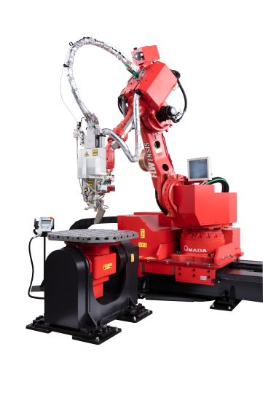
FLW-3000 ENSIS M2
Compact Fiber Laser Welding cell with new space-saving cabin design and variable beam control

By combining the FLW welding cell with the latest ENSIS fiber laser technology, AMADA takes laser welding to a new level and noticeably reduces production cycles. The ENSIS-3kW fiber laser and the variable beam control excel at the most different welding tasks. The weaving process effortlessly bridges larger gaps and, if required, an additional push and pull welding wire supply can be activated.

New, compact cabin design
The compact fiber laser welding cell now offers the user a stationary variable twist and tilt table as well as a two-station rotary table integrated in the cabin wall, significantly reducing cycle times. Thus, this smallest of the FLW-ENSIS expansion levels fits perfectly into production environments with limited space.

Effortless bridging of large gaps
Just like the larger models of the FLW-ENSIS fiber welding laser (M3 and M5), the new FLW-3000 ENSIS M2 model processes significantly higher gap dimensions than conventional laser welding machines. With the help of the variable beam control the 3 kW fiber laser adjusts to the different material requirements in the welding process. In ring mode, for example, the welding beam can be fanned out in a ring shape and the innovative weaving process allows the laser beam to oscillate with the integrated rotating optics if required. For particularly large gaps, the so-called push-pull welding wire feeding can also be activated.

Perfect quality due to adjustable welding depth
The FLW-3000 ENSIS M2 laser welding cell enables precise welding of even thin-walled sheets and leaves practically no residue, deformation or discoloration on the rear side. This outstanding quality feature results from the precisely defined energy input of the fiber laser, whose strength and range in the welding process can be individually controlled in accordance to material requirements.

Welding in record time thanks to powerful oscillator
The proven ENSIS technology with the oscillator from AMADA's own development, which leaves conventional welding systems far behind, enables special performance. The FLW-3000 ENSIS M2 combines various materials highly effectively in up to half the

conventional time. Even with overlap welding, the FLW-3000 ENSIS M2 requires only a fraction of the time otherwise required for the entire welding process, and the welding is extremely resilient. In addition, FLW-ENSIS performance is equally secure during butt welding, as well as welding with wire supply, whereby it even features a variance option to weld with or without wire.
(approx. 2,650 characters)

Technical data FLW-3000 ENSIS M2
Laser | Own-developed fiber laser source with patented variable beam control
Laser power | 3000 W
Robot | 6 axes industrial robot
Special feature | One stationary twist and tilt table  Two-station turn table integrated in the cabin wall
Safety feature | Safety cabin corresponding to T2 safety category for man-less operation

Image material will be handed out later
Source: AMADA GmbH

Further information:
AMADA GmbH
Press contact: Nicole Willuhn
Amada Allee 1
42781 Haan
Phone: +49 2104 2126-115
E-Mail: nicole.willuhn@amada.de
www.amada.de

Please provide evidence copy in the event of reproduction.

Press release 4

AMADA HG-1003ATC
The solution in the race with short delivery times and decreasing lot sizes

The fully automatic tool changers (ATC) in AMADA's HG press brakes cut setup times drastically compared to conventional systems. This maximizes manufacturing efficiency, especially in the case of small runs of complex parts demanding correspondingly frequent tool changes.
The automatic tool changer for maximum flexibility

Upper and lower tools are placed precisely and in the shortest possible time in the tool clamping, and set-up times are reduced by a good 70 percent compared to conventional systems. For example, the HG-ATC can set up 32 tools in just 36 seconds. In contrast to other press brakes with automatic tool changers, the HG-ATC allows each punch to be set up both positively and negatively in order to handle a wide variety of complex part geometries. The HG-ATC can even handle bending lengths of 5-10 mm effortlessly, as it also has a particularly small tool pitch. One HG press brake with automatic tool changer (ATC) can therefore effortlessly replace two conventional machines to be set up manually. This applies both to the HG-1003ATC with a press force of 1000 kN and a beam length of three meters and for the larger HG-2204ATC with a press force of 2200 kN and a beam length of four meters. Both systems are therefore perfect for short runs with frequently changing parts, and especially for complex parts even when manufactured as single items. What is more, all the tools are safely stored away in the automatic tool changer ATC and the risk of damage, for example when they are removed or installed, is eliminated.

External programming increases machine utilization
The state-of-the-art 3i control and external programming via the VPSS 3i Bend software noticeably shortens the preparation and increases the productivity of the HG-ATC. After loading the 3D-drawing, the software automatically calculates the set-up plan and bending sequence, as well as the necessary tools.
Latest feature of the HG-1003ATC
The latest generation of the HG-1003ATC presented at the exhibition offers advantages especially for long bending parts: The three-point measurement actively includes the crowning system in the angle measurement. The bending angle of the part is measured left, center and right to ensure a constant result over the entire length.

Technical data HG-1003ATC
Press force | 1000 kN
Press beam length | 3000 mm
Stocker for punches / dies | 15 / 18
Opening height | 600 mm
Automatically driven foot pedal | Standard
Active angle measurement system | Bi-S

Image material
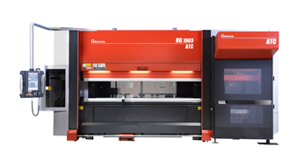 | The Automatic Tool Changer  (ATC) in the AMADA HG series  of press brakes ensures minimum  setup times.
Source: AMADA GmbH

Further information:
AMADA GmbH
Press contact: Nicole Willuhn
Amada Allee 1
42781 Haan
Phone: +49 2104 2126-115
E-Mail: nicole.willuhn@amada.de
www.amada.de

Please provide evidence copy in the event of reproduction.

Press release 5

EG-6013AR
Automated bending for small and complex bending parts

The EG-6013AR is equipped with an extremely versatile automatic robotic system as well as a special back gauge sensor system for high productivity.

The system components of the EG-6013AR ensure maximum precision and long, unmanned running times in automatic mode. The machine comprises a servo-electric press brake with a press beam length of 1,300 mm and a press force of 600 kN. This works in conjunction with a robot that moves parallel to the machine, an automatic tool changer and also a gripper changer.
Easy loading and unloading
The 6-axis robot performs the loading process from different positions. That leads to effectively reduced downtimes and increases productivity significantly. At the same time, several alternative unloading options are also available. The completed parts are stacked by the robot or, if this is not possible, placed either in boxes or on a synchronized conveyor belt.
Automatic tool changer and back gauge
The robot not only loads and deposits the parts, it also automatically changes both the bending tools and grippers and handles the part during the entire bending process. In order to enable fast processing, the robot also supports motion sequences that are not possible with manual operation. In this way, the mechanical grippers can also be moved around the tools in the working area of the press in order to optimally support the part following.

The back gauge of the EG-6013 AR, equipped with tactile sensor technology, detects the position of the workpiece before bending in X and Y direction and intervenes automatically to correct tolerances. The optimized back gauge system therefore allows even small and complex parts to be manufactured with maximum precision.

Technical data EG-6013AR
Press capacity | 600 kN
Beam length | 1300 mm
Stroke | 150 mm
Open height | 635 mm
Back gauge | 7 axes
Approach speed | 220 mm/s
Axis | Robot with 6 axes,  1 linear axis
Layout | 6000 x 3600 mm
Automated Tool Changer ATC | 10 Stocker
Automated Gripper Changer AGC | 3 Grippers
Illustration
More than just loading and unloading: The automatic robotic system within the AMADA EG-6013AR performs a wide range of tasks.
Source: AMADA GmbH

Further information:
AMADA GmbH
Press contact: Nicole Willuhn
Amada Allee 1
42781 Haan
Phone: +49 2104 2126-115
E-Mail: nicole.willuhn@amada.de
www.amada.de

Please provide evidence copy in the event of reproduction

Press release 6

EG-4010

The innovative EG-4010 press brake for maximum productivity and ergonomics

The new press brake EG-4010 completes the AMADA portfolio as the first servo-electric powered, ergonomic press brake with the patented AMADA DSP system and sets standards with regard to speed, convenience, reduced power consumption and intuitive programming.

Low-maintenance electric drive results in high speeds
With the EG-4010, AMADA now introduces a compact press brake featuring low power consumption and high output; high approach and bending speeds guarantee short cycle times. The electric drive ensures low maintenance requirements, because oil changes, for example, are not required. The precisely positioned beams ensure precise repetition (0.001 mm) and the utmost level of quality.

The latest generation in controls
As the latest generation of AMADA equipment, the EG-4010 features a network-compatible, user-friendly and intuitive control system (AMNC 3i) which is able to perform bending tasks in a fast and straightforward manner.

Ergonomic features and durable equipment frame
In response to the high demand for ergonomically designed equipment, the EG-4010 offers numerous such features, such as an adjustable work chair, height-adjustable front table and foot rest, as well as a height-adjustable control panel with left or right side positioning for the utmost operating convenience. Due to its high stability, the newly designed equipment frame of the EG-4010 also accommodates the processing of a diverse range of sheet-metal thicknesses. Its compact construction also enables space-saving placement in small production facilities, thereby increasing productivity.

Optional active angle measurement and Delta-X back gauge
The angle measurement system Bi-J by AMADA, which is positioned between the lower tools, provides the highest possible accuracy for all materials and thicknesses up to 6 mm; this means that test bending with wasted materials is avoided completely. With up to four sensors, even more sophisticated set-up plans can also be implemented. The Delta-X back gauge enables independent operation of the stop fingers in a process area of +/- 150 mm in X-direction and is equipped with two powered fingers.
(approx. 2,250 characters)

Technical data EG-4010
Drive | Dual Servo Drive
Press capacity | 400 kN
Beam length | 1050 mm
Back gauge | Delta-X, 5 Achsen
Ergonomy pack | Adjustable table and chair, 2 drawers
Active Angle Measurement system | Bi-J

Image material
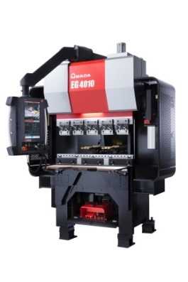 | With 400 kN press force and 1050 mm table length, the EG-4010 is perfectly suited for the production of small and complex parts.
Source: AMADA GmbH

Further information:
AMADA GmbH
Press contact: Nicole Willuhn
Amada Allee 1
42781 Haan
Phone: +49 2104 2126-115
E-Mail: nicole.willuhn@amada.de
www.amada.de

Please provide evidence copy in the event of reproduction

Press release 7

HFE3i-5012
Allround-solution for maximum flexibility, safety and ergonomics

Based on the solid foundation of the HFE series, the network-compatible press brake HFE3i-5012 provides an all-round solution for almost all bending tasks.

With a processing spectrum from 500 kN to 4,000 kN and bending lengths from 1,250 to 6,000 mm, the HFE3i series offers solutions for many bending tasks. Due to this high flexibility and an opening width of 480 mm, the HFE3i-5012 masters a broad range of material thicknesses as well as complex part geometries. The ergonomic solution improves working conditions and
relieves the operator in the working process.

State-of-the-art safety systems and back gauge solutions
The latest generation of the laser-based safety system AKAS (AKAS 5) ensures maximum safety and ease of use. The HFE3i-5012 also features the latest FAST Finger back gauge solution, which ensures high processing speed in the safety zone area. AMADA's own AFH tooling system is optimally adapted for use in the HFE3i-5012 and effectively minimizes set-up times thanks to the stage-die concept.

Network-compatible AMNC3i controller
The HFE3i-5012 includes a network-compatible, user-friendly and intuitive control system (AMNC 3i) which allows bending tasks to be performed in a fast and easy way. The 18.5" multi-touch screen features four different programming options (teach mode, direct mode, 2D and 3D mode) for a high-level of flexibility and productivity.

Comprehensive options
Additional to the standard equipment of the HFE3i 5012, producers are provided with a few options to perfectionize their production process. The Delta-X back gauge allows independent operation of the fingers at high speed in a working range of +/- 150 mm in
X-direction and is equipped with 2 FAST fingers. The AMADA BI-J
angle measuring system offers maximum accuracy from the very
first part.

(ca. 1900 characters)

Technical data HFE3i-5012
Press capacity | 500 kN
Beam length | 1250 mm
Stroke | 150 mm
Open height | 480 mm
Back gauge | Delta-X, 5-axis with FAST-finger

Image material
Based on the solid foundation of the
HFE series, the networkable press brake HFE3i-5012 offers an all-round solution for almost all bending tasks.

Source: AMADA GmbH

Further information:
AMADA GmbH
Press contact: Nicole Willuhn
Amada Allee 1
42781 Haan
Phone: +49 2104 2126-115
E-Mail: nicole.willuhn@amada.de
www.amada.de

Please provide evidence copy in the event of reproduction.

Press release 8

AMADA IoT concept V-factory

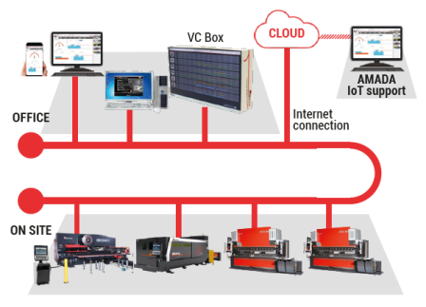
AMADA’s IoT concept with production monitoring and interactive support

The next generation of the comprehensive and network-based machine monitoring concept enables maximum control in the production process. My V-factory shows the entire connected production environment at a glance. The optional new IoT support is the second element that offers a direct customer service concept for error avoidance and immediate support.

Production at a glance - simple, clear, at any time
In times of constant change, a producer must truly be able to adapt to many risk factors. Varying lot sizes and growing customer demands in regard to the complexity of components, a shortage of skilled workers and technical experts, as well as the demand for short throughput and delivery times are a real challenge to any entrepreneur. AMADA's V-factory concept offers practical solutions to counter bottlenecks and downtimes in advance.

The foundation of success: Efficient machine monitoring and interactive customer service
My V-factory displays the production environment on a single interface for a comprehensive machine monitoring The customer can quickly and easily read the machine status like the running and completed programs. It informs about the exact running and set-up times, differentiating exactly between standby and downtimes. These and many other features, such as for production quantities, thus represent an ideal system for optimally designing productive processes.

The worst case is also taken care of, with a new AMADA service concept that takes effect in the case, when the customer is not aware of machine errors or potential dangers to his production process. As incremental part of V-factory, the AMADA IoT support provides fast and reliable assistance with maintenance issues. Depending on the customer's wishes, it either switches on automatically in the event of warning messages or otherwise, reacts only after the customer decided to establish the contact by himself. In this way, many service calls can be avoided in advance, while at the same time the customer's data security is guaranteed.

Another useful feature is certainly the remote service, which is popular with AMADA customers and has already enabled remote maintenance in the past. Recommended is the use with AMADA AMNC 3i control and the VPSS3i Software Solutions Pack. With this software package, virtual prototype simulation in particular is invaluable for the user, as errors can be avoided before they occur.

(approx. 2,486 characters)

Image Material

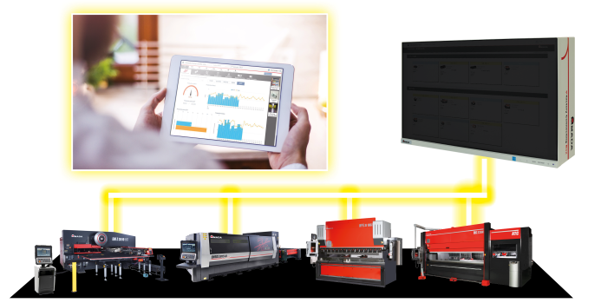

The next generation of the comprehensive and network-based machine monitoring concept enables maximum control in the production process.

Source: AMADA GmbH

Further information:
AMADA GmbH
Press contact: Nicole Willuhn
Amada Allee 1
42781 Haan
Phone: +49 2104 2126-115
E-Mail: nicole.willuhn@amada.de
www.amada.de

Please provide evidence copy in the event of reproduction

About AMADA GmbH

The AMADA Group is one of the world's leading manufacturers of sheet metal working machines. AMADA GmbH offers a comprehensive range of cutting, bending, welding, punching and laser technologies. Modular automation components, software applications and a wide range of tools round off this broad portfolio. In addition, AMADA offers its customers a wide range of services. The AMADA Group was founded by Isamu Amada in Japan in 1946. The German subsidiary AMADA GmbH has existed since 1973.

Further information:

 | AMADA GmbH  Amada Allee 1  42781 Haan - Germany  Press Contact:  Nicole Willuhn  Phone: +49 2104 2126-115  E-mail: nicole.willuhn@amada.de,  www.amada.de |  | AMADA ITALIA S.r.l  Via Amada I., 1/3  29010 Pontenure (Piacenza) - Italy  Press Contact :  Sonia Sirocchi  Phone : +39 (0)523 872111  E-mail: lorella.groppi@amada.it  www.amada.it
 | AMADA UK Ltd  Spennells Valley Road,  Kidderminster  Worcestershire, DY10 1XS - England  Press Contact:  Cathryn Morris  Phone: +44 (0) 1562749500  E-mail:cathryn.morris@amada.co.uk  www.amada.co.uk |  | AMADA Europe  Paris Nord 2  96 avenue de la Pyramide  93290 Tremblay-en-France - France  Press Contact :  Valérie SALAVIN  Phone : +33 (0) 1 49 90 30 00  E-mail: valerie.salavin@amada-eu.fr
AMADA SA
Paris Nord 2
96 avenue de la Pyramide
93290 Tremblay-en-France - France
Press Contact :
Jean Pascal Reyrolle
Phone : +33 (0) 1 49 90 30 00
E-mail: jpreyrolle@amada.fr
www.amada.fr

