Blechexpo press folder 2017, October 2017
Press release 4

The new 9-kW AMADA LCG-3015AJ laser cutting system
Perfection through thick and thin
The 9 kW version of the AMADA LCG-3015AJ allows high-speed and top-quality laser cutting also of medium
thickness materials – and provides a quality of cut never previously achieved by a fiber laser. Three 3-kW fiber laser modules form the basis for the 9-kW version of the AMADA LCG-3015AJ laser cutting system.

The new 9-kW version of the AMADA LCG-3015AJ completes the range of proven AMADA fiber laser systems for the high-performance segment. The high output permits the very high-speed and top-quality processing of thin and mid-thickness materials. However, the system also supports the precise, reliable processing of exceptionally thick sheets as well as the work in areas where nitrogen is used as an assist gas. The high laser beam quality and the so-called “silky cut” method permit cutting qualities previously unachievable with lower-powered fiber laser systems.
Latest generation of laser modules
The AMADA LCG-3015AJ 9 kW owes its strength to the new, third generation AMADA resonator. It contains just three 3-kW fiber laser modules which combine to form the most powerful unit currently available on the market. The smaller number of fiber laser modules makes the system significantly less susceptible to malfunctions than conventional fiber lasers, which contain multiple modules connected in sequence together with the corresponding number of plug-in contacts. In this way, the lean AMADA laser unit of the LCG-3015AJ 9 kW minimizes stoppage times during practical operation and once again improves machine availability.
Alternative to the CO₂ laser
The AMADA LCG-3015AJ 9 kW can be regarded as a appropriate, high-performance alternative to CO₂ lasers. It excels in terms of energy consumption: Although the output power has increased by a third compared with the 6-kW laser, the energy consumption of the 9-kW version is not significantly higher. By contrast, a similar increase in power in a CO₂ laser would require significantly higher consumption levels. Another advantage: The AMADA fiber laser has a modular structure and its short wavelength means that there is no need for a deflecting mirror. Efficiency can be increased further through automation options such as the MP-Flexit loading and unloading unit or the ASF-EU loading and unloading tower. Automatic part sorting is done by the Takeout-Loader (TKL).

approx. 2,600 characters

Technical data LCG-3015AJ
Laser | Amada fiber laser
Laser output | 9000 W
Working area | 3000 x 1500 mm
Positioning speed  (simultaneous X-Y) | 170 m/min

Illustration

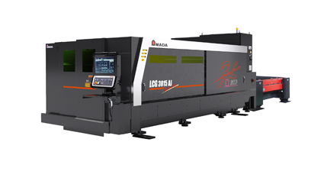 | The LCG-AJ is available in the performance classes 2,000, 3,000, 4,000,  6,000 and 9,000 Watts.
Source: AMADA GmbH

For further information:

AMADA GmbH
Amada Allee 1
42781 Haan - Germany

Press contact: Nicole Goldhorn

Phone: +49 2104 2126-0
E-mail: nicole.goldhorn@amada.de

www.amada.de
Please provide specimen copy if reproduced

